

**Software Design and development project**

Project Documentation

**Unit Coordinator:** Jamie Shield

**Tutor:** Dr.Zakiullah Khan

**Group Team member:**

Adarsha Mani Lamichhane, 12140071

Bandana Kapali, 12127043

Javagal Srinath Narayan, 12131231

Maruf Siddique, 12132167

Table of Contents

**1.** **Introduction** 4

1.1 Goals and overview 4

1.2 Scope 4

**2.** **Requirement Specification** 5

2.1 Functional requirement 5

2.2 Non- functional requirements 5

**3.** **Feasibility types** 6

3.1 Technological 6

3.2 Economic (cost-benefit analysis) 6

3.3 Operational 7

3.4 Legal 7

3.5 Social 7

3.6 Time 7

**4.** **Architecture** 9

3.1 Software Architecture 9

3.2 Layer Modelling 10

**5.** **Database Design** 11

**6.** **Work Breakdown Structure (WBS)** 12

**7.** **Schedule (Gantt Chart)** 13

**8.** **User stories** 14

7.1 As an admin 14

7.2 As a student 14

9. **Class Diagram** 16

**10.** **Sequential diagram** 16

11.**Risk estimate in the project** 18

11. 1 LIST OF RISKS INVOLVED IN THIS PROJECT 19

**12.** **Quality Assurance Plan** 21

13.2 Quality Metrics 22

**13.** **Implementation of User Stories** 24

14.1 User Story (User): 24

14.2 User Story (Admin): 24

**Implementation of the user story:** 24

14.3 Test of the user story implementation: 24

**14.** **GUI Interface of the system** 27

**15.** **Monitoring and reporting** 37

**16.** **Reference list** 38

**17.** **APPENDIX** 39

17.1. APPENDIX A : Screenshots of all the user story implementations 39

Admin Login 39

Student Login 40

Adding a new Administrator 41

Adding a new Campus 42

Admin Details Page 43

Campus Details Page 43

Adding a new Student Form 44

Adding a new Equipment Form 44

Student Details Page 45

Equipment Details Page 45

Figure 1 : N-tier 5

Figure 2 : MVP architecture 6

Figure 3 : Database design 7

Figure 4 : WBS 8

Figure 5 : Gantt Chart 9

Figure 6 : Use case diagram 14

Figure 7 : Class diagram 15

Figure 8 : Sequential diagram (Admin) 16

Figure 9 : Sequential Diagram (User) 17

Figure 10 : Student Search window 23

Figure 11 : Student register form 24

Figure 12 : Campus register form 25

Figure 13 : Equipment search box 26

Figure 14 : Equipment registration box 27

Figure 15 : Login screen 28

Figure 16 : Admin dashboard 29

Figure 17 : Student dashboard 30

# **Introduction**

CQU lab management system is an application build for the staffs and student to quickly find lab equipment available in all the campuses. Lab management system offers a set of key features that will support a modern laboratory operation. The main aim of our application will be to eliminate the spreadsheet and paperwork and to organize and record all the lab equipment. This report will provide the brief discussion on this system operation, design, requirement, purpose, quality management, risk management etc.

The system here is developed using java NetBeans and all the data and information will be saved in Java DB database.

## 1.1 Goals and overview

The main objective of the system is to eliminate the spreadsheet record of the lab equipment and keeping track of all students, staffs, and lab equipment. The main objectives of this system are as follows:

* List all the availability of lab equipment
* Develop database to record all the equipment
* Develop database to record all the students and staff’s details
* Eliminate the spreadsheet and paperwork

## 1.2 Scope

The scope of this application is listed below:

Table : Scope of the application

|  |  |  |
| --- | --- | --- |
| SN | Feature | Description |
|  | Admin | System should allow admin to view and edit all the information in the system. Only admin can add delete student and staff’s details. |
|  | Equipment Search | System should allow users to search all the lab equipment. |

## **Requirement Specification**

## 2.1 Functional requirement

This application will be a basic lab management system for CQU university. Functional requirements for the system are:

* Main Admin: System must have one admin. The admin will have its unique identification to enter in the system. The admin will be able to add, delete the student details.
* User: User can create their profile in the system and will be able to borrow and withdraw the laboratory equipment.

## 2.2 Non- functional requirements

* Security: The system must be secured enough. Only admin can add or delete the staff and student details. Except admin and user, no one else should have access of the system
* Updated: The system should be up to date as per situation requirement.
* Performance: The performance of the application should be fast enough and should be able handle unexpected and expected errors.

# **Feasibility types**

Feasibility analysis is the process of confirming that a approach is possible & makes sense. This can be used to validate assumptions, constraints, decisions, approaches & business cases. Some common types are mentioned below: -

## 3.1 Technological

This is a practical measurement. Technological criteria provide the most appropriate technical solutions to the discovered problem. According to this scenario, the technical interface of their current system should modify or upgrade to a new system. According to the IT manager’s idea

* They need technical professional to maintain the system.
* They need to invest more on Technology product.
* The selection of Database & programming language may affect the Existing technical incompatibility.
* The system might be smoother because of reconstruction (Spacey, 2017).

## 3.2 Economic (cost-benefit analysis)

Economic is deciding the cost of the entire product. After analyzing the requirements, the cost can be estimated. While developing the project, cost is not an exact amount because sometimes project cannot finish on time, some errors may occur etc. Fluctuation of cost can occur due to this reason. From the very first beginning we have chosen one of the staged life cycle models to develop the project. There are some important things to include with this economic criterion.

* An estimated cost of the product can fulfill user requirements.
* Estimated cost is enough to finish the project.
* 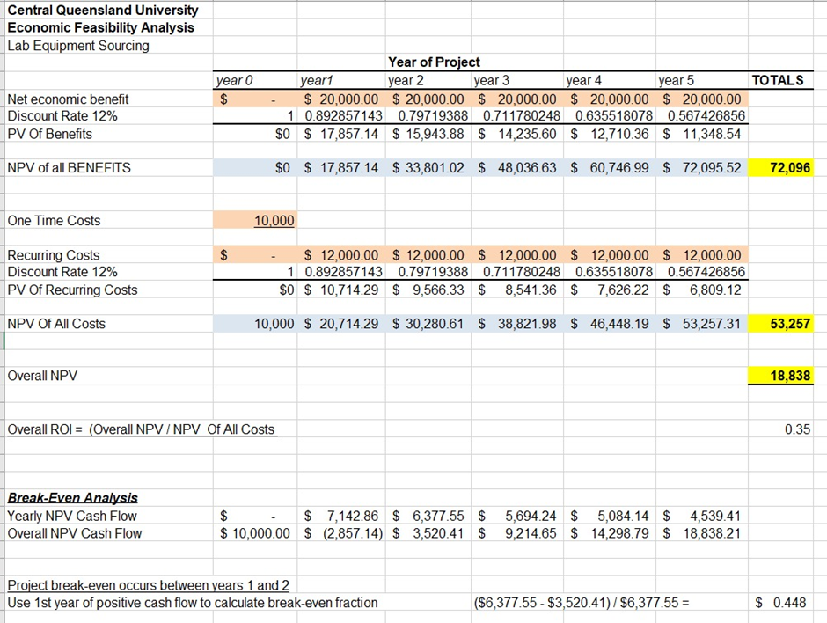Can do the project without any other additional charges (Daniels, 2021).

## 3.3 Operational

This will check how the designed product performs in the real operational environment. When we apply this criterion there are some important questions may arise

1. How does the user will feel about the new system?
2. Does the system have high performance, efficient page loading, data storage?
3. Do they contribute to the proposed system?
4. The proposed solution may perform in good in the real environment or not.
5. Is the system secured?
6. Does the system provide end users timely, pertinent & usefully formatted information?

(Spacey, 2017)

## 3.4 Legal

It determines whether the proposed system conflicts with legal requirements e.g., a Data Processing system must comply with the local Data Protection Acts. Most of the time this criteria model depends on government rules. Once the product is finished it will check under the government. It will check what kinds of functions are available in the system & are there any functionalities that are not suitable, and the product is under the rules and regulations of the government or not. At the end this system should be registered under government. Then no one can create under their name (Daniels, 2021).

## 3.5 Social

People will talk about the system when it operates in real environment. Let’s think according to this scenario it is a good system. Then what will happen? Everyone will talk about this system, and they also motivate to apply this into their operation also. According to this system customer is one of the most important part of their society. Reservation system should realize the user needs as well.

1. Social communication will be less for the new IT system because all the things will be done easily on computer & social interaction will be reduced.
2. Society will be lazy as things are in hand on a button click.
3. Society will need to be educated to IT systems (Daniels, 2021).

## 3.6 Time

Ability of finishing the project on time is measured under this model. At the beginning of the project the client and software Development Company make the agreement. After how many times periods client will get the product is calculated. Customer satisfaction is more needed in this stage.

* Development time may need longer than expected.
* On time development will increase the chance to engage the organization into the business
* Delay delivery of system may put them out of getting contract because demand created earlier.
* In case of delay delivery of the system, someone else may capture the market (Spacey, 2017).

# **Architecture**

# 3.1 Software Architecture

The CQU lab management system will be developed in the single tier architecture that means that all the 3 layers that is presentation, logical and data layers will be tightly connected, and all code will keep on single machine. This will also enable high security.

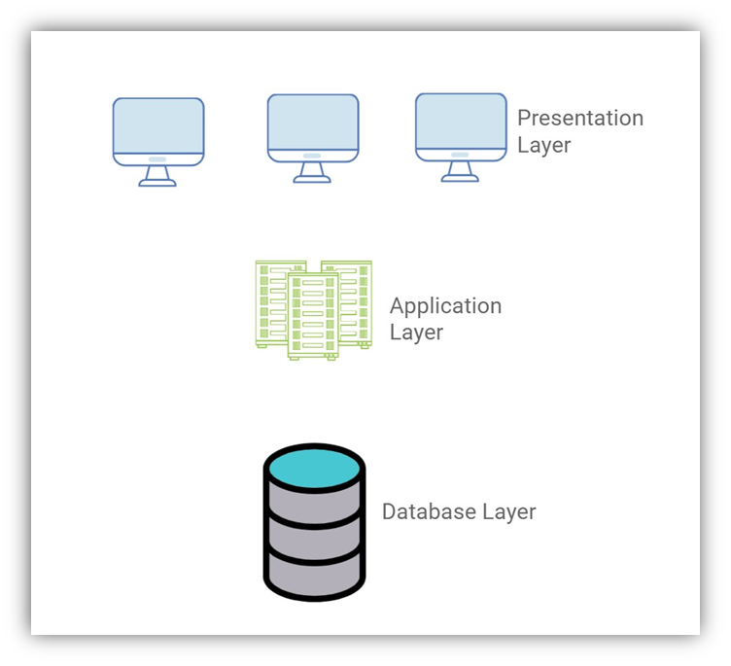N-tier is very easy to use because the application is divided into independent tiers, one can easily reuse each tier for other software projects (Alvatar,2017). N-tier is very simple and friendly for the development so that different team members can work in different Tiers

Figure : N-tier

To understand in a very simple ways, single tier architecture has components as presentation logic, business logic and data access logic. Presentation logic where the tasks are translated to something that user can understand and logic tier coordinated the application, process commands and makes logical decision and performs calculation. Logic tier also moves and process the data between the surrounding layers. However, data access tier stores the data and information and retrieved it’s from the database and passed back to the logic tier so that logic tier can then process it.

## 3.2 Layer Modelling

CQU lab Management system will follow Model View presenter pattern (MVP). The MVP patter is evolved from MVC patter. They both have same place: Model is data layer, which is responsible for accessing data, view is the view layer which is responsible for data display and presenter layer responsible for logic processing (li,Dan 2020).

Figure : MVP architecture

The presentation layer of the system will translate all the requested task and the outcome results are understandable to user. The business layer data form the database layer and transfers it to the presentation layer and the database layer handles all the data and transfers it to business layer.

# **Database Design**

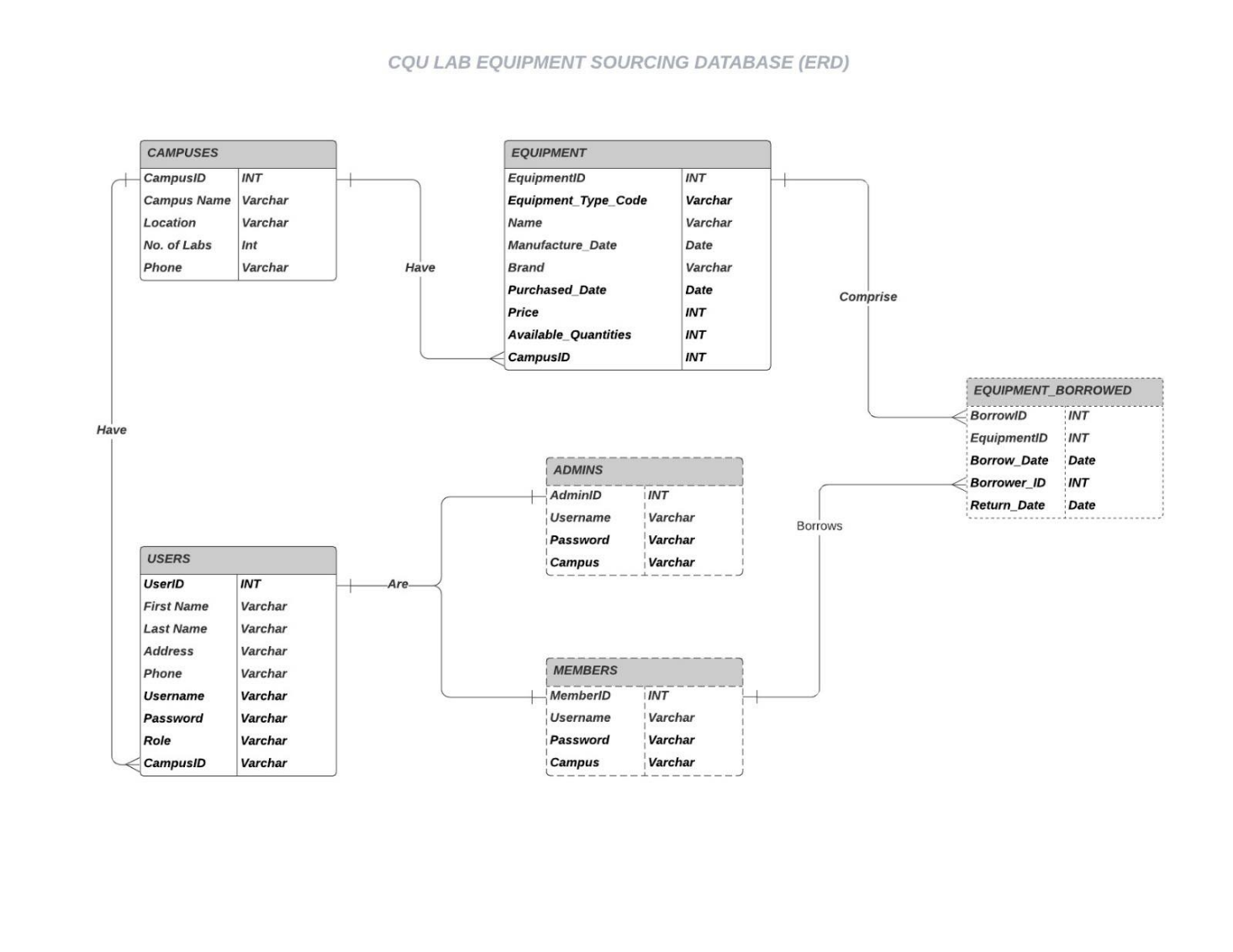 Database design starts with a conceptual data model and produces specification of a logical schema (Watt, 2014). The main objective of database design is to produce logical and physical design models of the database system. The database design will then decide how and what data must be stored in the system. Here is the design documentation of the CQU lab Equipment Sourcing system:

Figure : Database design

# **Work Breakdown Structure (WBS)**

WBS in project management takes large, complex projects and breaks down the project scope into more manageable pieces to make it easier to plan, schedule and deliver. Tiers of project deliverables and tasks are created to support the planning, execution, and monitoring of projects. There are four main levels of a WBS, which are outlined below:

* **The Top Level:** The project title or final deliverable.
* **Controls Account:** The main project phases and deliverables.
* **Work Packages:** The group of tasks that lead to the controls account level.
* **Activities:** The tasks needed to complete the work package.

At the top of the work breakdown structure is the final deliverable. Immediately beneath that is the next stage of deliverables, which are the main tasks required to complete the project. Each of those five project phases—initiation, planning, execution, control, and closeout—branch off the main deliverable at the top. Once decided, they are then broken down into a series of tasks. These tasks, however, can be further distilled into smaller subtasks. The WBS, when created as thoroughly as possible, is the roadmap to guide us to completion of what would seem to be a very complicated project. However, when broken down with a WBS, the project suddenly becomes much more manageable.

Figure : WBS

# **Schedule (Gantt Chart)**

A Gantt chart is commonly used graphical depiction of a project that helps in scheduling, managing, and monitoring specific tasks and resources in a project (Grant, 2021)

As shown in the Gantt chart it is possible to check on progress with a quick glance. You can easily see:

* a visual display of the whole project,
* timelines and deadlines of all tasks,
* relationships and dependencies between the various activities,
* project phases

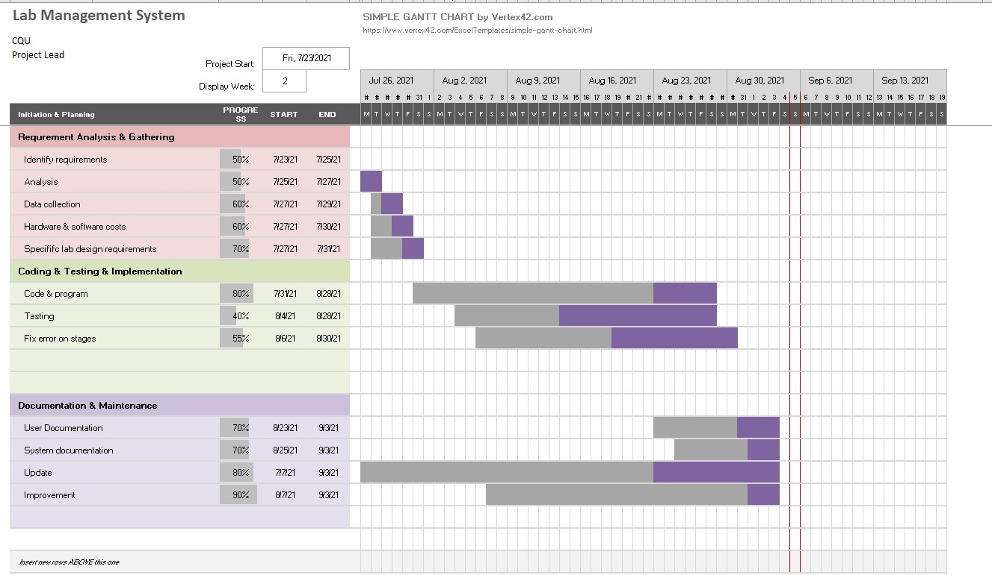

Figure : Gantt Chart

We can clearly understand the project progress by phases. This also helps to understand percentage of work completed, start date and due dates. It gives project managers visibility into team workloads, as well as current and future availability, which allows for more accurate scheduling.

The activities are divided into different tasks like identify requirements, analysis & data collection, hardware & software costs, specific lab equipment, coding & testing, fixing errors, user & system documentation, updates & improvements etc.

# **User stories**

A user is a general explanation of a software feature written from the end user perspective. The main purpose of the user stories is to articulate how a software will provide and information to the customer (Rehkoph, 2021). The user stories provide important context to development team before a project begins. This can help development team think more critically and creatively (Francino, 2019). So, for the CQU lab management system there are three types of users:

* Admin
* User (Student)

The requirements of the system can lure the following user stories:

## 7.1 As an admin

* I can login into the system
* I can add new student ID’s
* I can delete and edit the existing student details
* I can add equipment details (Name, ID, Location)
* I can delete and edit the existing equipment details
* I can view list of student details
* I can view list of equipment details
* I can add/Delete campus details
* I can track the student history
* I can see student details individually
* I can logout of the system

## 7.2 As a student

* I can login into the system
* I can view the list equipment in the laboratory
* I can search the equipment as per my work
* I can book the equipment
* I can view the history of my own
* I can see the due date of the equipment which I borrowed from the laboratory
* I have an option to withdraw my equipment before the due date
* I can logout of the system**Use case diagram and description**

Use case diagram describes the high-level functions and the scope system. Use case diagram model describes the behaviour of the system and helps to capture all the requirements of the application. The figure below shows the Use case diagram of the Lab Equipment System:

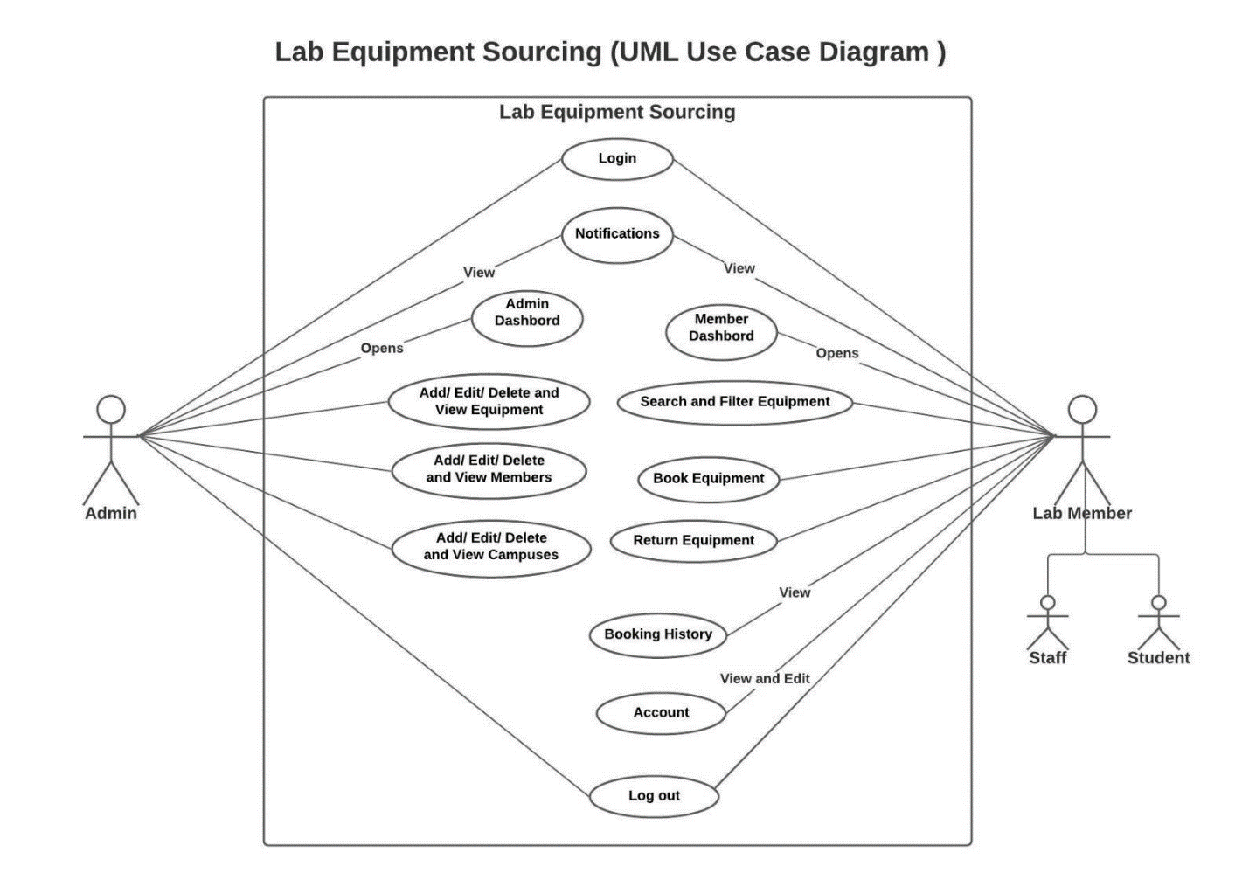

Figure : Use case diagram

# **Class Diagram**

Class diagrams are the building blocks in the object-oriented language. Class diagrams are used to show the different entities and attributes of the system. Classes in the class diagram are represented in the box, the top part contains the name of the class whereas the middle part contains attributes, and the last bottom part represents the operations which are associated with the class.

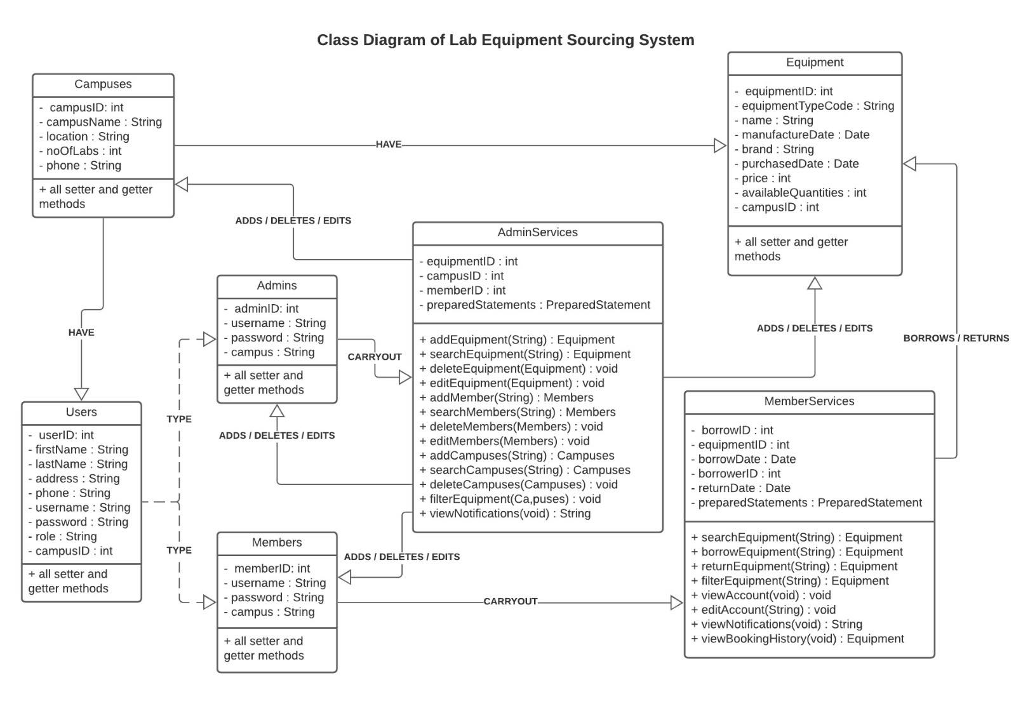The following figures is a class diagram of lab equipment sourcing system:

Figure : Class diagram

# **Sequential diagram**

Sequence diagram is defined by the UML manual as “a diagram that shows object interactions arranged in time sequence” (Baqais and Alshayeb, 2018). Sequence diagram is a UML diagram which illustrates the sequence of the message between the objects. Sequence diagram helps to understand the relation between the objects. Figure below shows the interaction of admin(actor) and the layer entities:

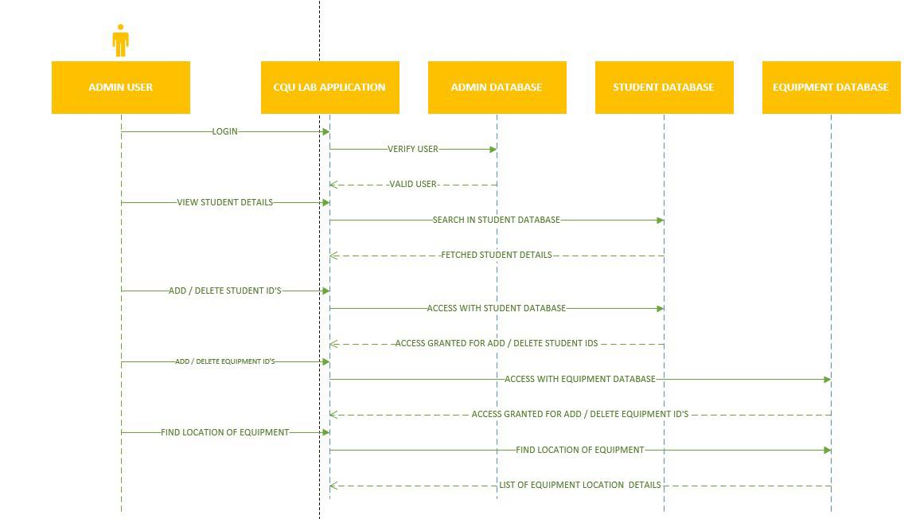

Figure : Sequential diagram (Admin)

Above diagram shows the interaction between admin and the layer entities. The admin logins to the CQU application. In the homepage we can see admin logins with their credentials authentication and only admin can view staff and student details and can add, delete staffs and students.

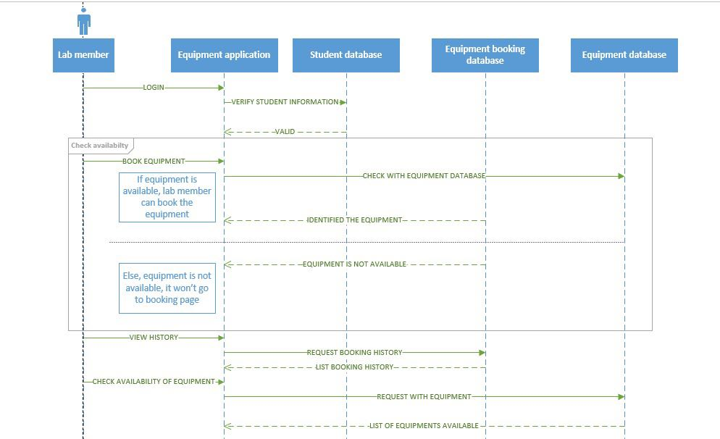

Figure : Sequential Diagram (User)

Here in the above diagram, we can see the interaction between the lab members and the layers. In the homepage we can see that the lab members logins with there credentials and if that is valid then the lab members can use rest of the function like booking equipment and checking the availability of the equipment.

# 11.**Risk estimate in the project**

In software development, risk may arise in various elements. The project manager must take the responsibility to identify the probability of risks and make the necessary plan to mitigate at early stage (Gracia,2019). In this area, the risk management plan came into the picture.

The risk management plan helps to take up the response to each risk and identify the alternative solutions. This will help us to develop the software at high quality manner. In this project, “Equipment lab sourcing”, we have listed the risks which may arise while developing the software, as well as we analysed the impacts which may create from those risks. It helps to prioritize those risks which creates high impact in our project. The PM and BA identified the list of risks which may affect the project in various aspects. It might be the serious thread to time management, scheduling and even in the quality of the software product. Those risks need to be mitigated from various solutions.

P – It stands for the occurrence of risk

I – It stands for the percentage of impact which may rise in the project.

J - P* I J stands for Jeopardy of the project.

## 1 LIST OF RISKS INVOLVED IN THIS PROJECT

|  |  |  |  |  |  |
| --- | --- | --- | --- | --- | --- |
| S.NO | Risk | P | I | P*I | Solution / Mitigation |
| 01 | Requirement changes frequently by client side | 6 | 7 | 42 | The project manager has to understand the initial stage of the document, Identify the queries. Have the meeting with the project owner frequently to get clear idea about their requirement before the initiation of work. |
| 02 | Data Integration | 5 | 3 | 15 | In this project “*Lab equipment sourcing”* it is important to maintain the proper datasets. There are various tools to integrate the multiple datasets. By using those tools, it is easy to mitigate those risks. |
| 03 | Communication problem between team members | 8 | 7 | 56 | It is the serious threat, where it may create serious impact to the project. It is mandatory to have internal discussion with their team members in daily basis. Updating their work in separate portal where every team member in the group can view their workings. It needs to be rectified at the initial stage itself. |
| 04 | Task need to be spitted equally | 7 | 7 | 49 | First stage of reducing those risks by analysing the skillsets of each team member in the group. Based on their understandings and skillsets, tasks need to be listed and shared equally within their group. |
| 05 | Data tracking | 6 | 5 | 30 | If the team members are updating their work in different DB, it creates difficulty in tracking those datasets. To overcome this issue, Centralized is the only option where helps to have access to all the other members in their group. |
| 06 | Lack of Expertise | 5 | 5 | 25 | If the user doesn’t have enough knowledge in handling the application, it may create the risks in multiple ways. To avoid this situation, The PM or other people who have involved in the project has to give KT (Knowledge Transfer) to the users of the application. |
| 07 | Upgrade platform | 4 | 3 | 12 | The application needs to update frequently, it may help to reduce some risks. Currently, the application is running as standalone. But it could be better to have cloud-based application to increase the performance of the system. |
| 08 | Team coordination | 6 | 7 | 42 | If there is any lang in team coordination, it will create the serious damage to the quality of the product. To overcome this issue, team building activities are helps to resolve those risks. |
| 09 | Inventory maintenance | 5 | 4 | 20 | The equipment needs to be checked frequently; it has a chance of getting damaged. The quality of each equipment has to be checked and update at some interval of time. |

# **Quality Assurance Plan**

The quality management plan is the necessary document required to manage the quality of the project effectively. Quality management is the process of planning, scoping, implementing, and monitoring of quality into all phases of the project from concept through the delivery aspects of the work (Patterson, 2019). In short, we can say that project quality management plan documents are a necessary document required for effective management of the project from planning to delivery.

The project quality plan is prepared during the planning phase of the project. Quality management involves planning, managing team, skill forming and other project planning things. The intended audience are the project manager, project teams, senior leaders, and stakeholders. There are so many tools associated with quality management plan some of them are:

* Quality Planning:

In quality planning the project manager codifies the standard of project and work on those standards to achieve the goal of the project.

* Quality Assurance:

Quality Assurance begins with the planning, designing, engineering. The quality which has been planned in the quality planning are implemented.

* Quality Control:

After all of planning and assurance, quality control is the last process under quality management. Things like monitoring the project metrics is done in this phase.

13.1 Quality roles and responsibilities

|  |  |  |
| --- | --- | --- |
| Name | Role | Quality responsibility |
| Dr. Zakiullah Khan | Client Representative | Quality Audit |
| CQU University | Project Owner | Quality Coaching and testing |
| Adarsha Mani Lamichhane  Bandana Kapali  Javagal Srinath Narayan  Maruf Siddique | Software Developers and testers | Functional testing and quality assurance analyst |
| Jamie Shield | Course Coordinator | Quality Audit |

## 13.2 Quality Metrics

|  |  |  |  |
| --- | --- | --- | --- |
| Metric | Standard | Measuring Method | Quality Criteria |
| User Friendly | The application needs to be user-friendly and should be easy to use. The application is flexible to use so user of any ages will be able to use the software. | Testing | The application should be user friendly and should run in any devices. |
| Cost of maintenance | The cost maintenance should be minimum | Auditing | The maintenance cost should be minimum that means all the cost of spreadsheet and paperwork should minimize. |
| Implication of the new technology | New tools and technology need to be use when necessary | Auditing | The tools and technology need to be up to date, and the framework must follow the MVP modelling. |
| Functionality | All the functional required that has been discussed should be implemented | Testing | No error must be found |
| GUI | The user interface needs to be simple, so any user can use it. | Testing and auditing | The GUI must be simple and attractive to the user. The colour combination should be simple and photoshop or any other tools must be used if necessary. |
| Performance | The performance of the application should be fast, and no latency should encounter during and tasks. | Testing | The vast data and files should be minimise to avoid latency. |

# **Implementation of User Stories**

## 14.1 User Story (User):

1. The system actors need to be able to access their own services assigned to them according to their role.

**Implementation of the user story:**

* The system actors are divided mainly into Admins and Members.
* A single login page appears at first when the system is started.
* According to their individual login credentials, they are identified as admins or members of the system.
* If the user is Admin of the Lab System, he is redirected to the admin dashboard where all the services assigned to an administrator is displayed and he will be able to access them all.
* If the user is Member of the Lab System, he is redirected to the Member dashboard where all the services assigned to a member is displayed and he will be able to access them all.

## 14.2 User Story (Admin):

1. Admin will be able to add, edit, delete, search and view the campuses, admins, students and lab equipment.

**Implementation of the user story:**

* Once admin logs in from the login page, he enters the Admin Dashboard.
* He can see all the accessible services on the dashboard itself and can choose to enter into any of them by clicking on the corresponding button.
* Admin has the full CRUD authority to carry out on all the models of the system. The models are Admins, Campuses, Lab Equipment, and Students.
* Upon clicking each button to access a service, the system will redirect the Administrator to a new page where he can either add, search, view, edit or delete the elements of the system.

## 14.3 Test of the user story implementation:

|  |  |  |  |  |  |
| --- | --- | --- | --- | --- | --- |
| Test No. | Test Name | Input | Expected Output | Actual Output | Remarks |
| LOGIN PAGE | | | | | |
| 1 | Login Portal Check  (For Admin Login) | * Username: **admin** * Password: **admin1** * **Login** Button Clicked | Admin Dashboard needs to be displayed. | Admin Dashboard was displayed. | **PASSED** |
| 2 | Login Portal Check  (For Member Login) | * Username: **student** * Password: **student1** * **Login** Button Clicked | Member Dashboard needs to be displayed. | Member Dashboard was displayed. | **PASSED** |
| ADMIN DASHBOARD PAGE | | | | | |
| 3 | ADD ADMIN BUTTON | * Clicked Add Admin Button | A new window to add a new admin will be displayed. | A new window to add a new admin was displayed. | **PASSED** |
| 4 | ADD STUDENT BUTTON | * Clicked Add Student Button | A new window to add a new Student will be displayed. | A new window to add a new Student was displayed. | **PASSED** |
| 5 | ADD EQUIPMENT BUTTON | * Clicked Add Equipment Button | A new window to add a new equipment will be displayed. | A new window to add a new equipment was displayed. | **PASSED** |
| 6 | ADD CAMPUSES BUTTON | * Clicked Add Campuses Button | A new window to add a new campus will be displayed. | A new window to add a new Campus was displayed. | **PASSED** |
| 7 | STUDENT DETAILS BUTTON | * Clicked Student Details Button | A new window to search the student will be displayed. | A new window to search the student was displayed. | **PASSED** |
| 8 | EQUIPMENT DETAILS BUTTON | * Clicked Equipment Details Button | A new window to search the equipment will be displayed. | A new window to search the equipment was displayed. | **PASSED** |
| 9 | LOG OUT BUTTON | * Clicked Log Out Button | Admin will return back to the login page. | Admin returns back to the login page. | **PASSED** |
| ADD ADMIN PAGE | | | | | |
| 10 | REGISTER NOW BUTTON | * Admin (Adarsha) details entered. * Clicked Register Now Button | “New Admin Added” prompt will be displayed. | “New Admin Added” prompt was displayed. | **PASSED** |
| 11 | CHECK ADMINS TABLE ON DATABASE | * Open [localhost / 127.0.0.1 / cqulabequipmentsourcing / admins | phpMyAdmin 5.1.0](http://localhost/phpmyadmin/index.php?route=/sql&server=1&db=cqulabequipmentsourcing&table=campuses&pos=0) on browser | Updated Admins Table will be displayed. | Updated Admins table with new Admin (Adarsha) displayed. | **PASSED** |
| 12 | BACK TO HOME PAGE BUTTON | * Clicked Back to Home Page Button | Admin will return back to the admin dashboard. | Admin returns back to the admin dashboard. | **PASSED** |
| ADD STUDENT PAGE | | | | | |
| 13 | REGISTER NOW BUTTON | * Clicked Register Now Button | “New Student Added” prompt will be displayed. | “New Student Added” prompt was displayed. | **PASSED** |
| 14 | BACK TO HOME PAGE BUTTON | * Clicked Back to Home Page Button | Admin will return back to the admin dashboard. | Admin returns back to the admin dashboard. | **PASSED** |
| ADD CAMPUSES PAGE | | | | | |
| 15 | REGISTER NOW BUTTON | * Melbourne Campus details entered. * Clicked Register Now Button | “New Campus Added” prompt will be displayed. | “New Campus Added” prompt was displayed. | **PASSED** |
| 16 | CHECK CAMPUSES TABLE ON DATABASE | * Open [localhost / 127.0.0.1 / cqulabequipmentsourcing / campuses | phpMyAdmin 5.1.0](http://localhost/phpmyadmin/index.php?route=/sql&server=1&db=cqulabequipmentsourcing&table=campuses&pos=0) on browser | Updated Campuses Table will be displayed. | Updated Campuses table with new Campus (Melbourne Campus) displayed. | **PASSED** |
| 17 | BACK TO HOME PAGE BUTTON | * Clicked Back to Home Page Button | Admin will return back to the admin dashboard. | Admin returns back to the admin dashboard. | **PASSED** |
| STUDENT DETAILS PAGE | | | | | |
| 18 | BACK TO HOME PAGE BUTTON | * Clicked Back to Home Page Button | Admin will return back to the admin dashboard. | Admin returns back to the admin dashboard. | **PASSED** |
| EQUIPMENT DETAILS PAGE | | | | | |
| 19 | BACK TO HOME PAGE BUTTON | * Clicked Back to Home Page Button | Admin will return back to the admin dashboard. | Admin returns back to the admin dashboard. | **PASSED** |

# **GUI Interface of the system**

The user interface can only be accessed by the authorised users. Each and every user interface is made using the scene builder.

**1. Login screen**

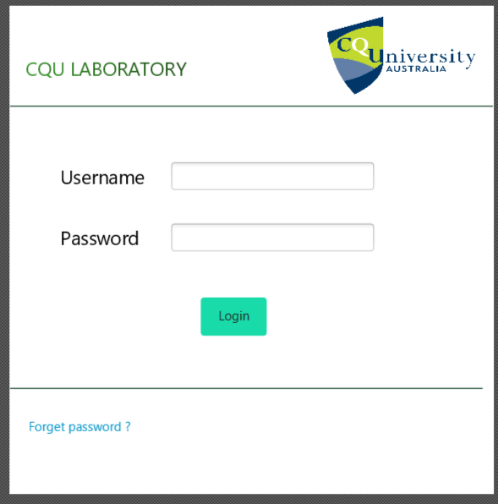

Figure : Login screen

**2. Admin dashboard**

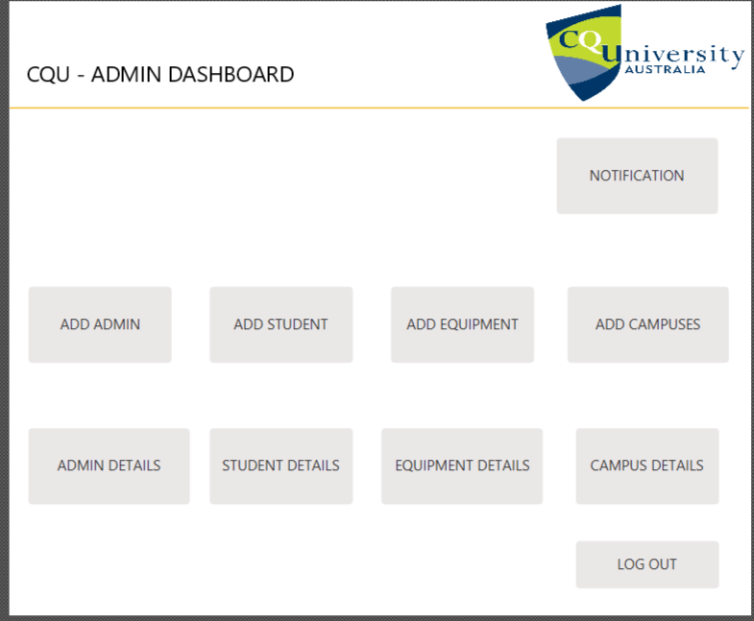

Figure : admin dashboard

**3. Add student details**

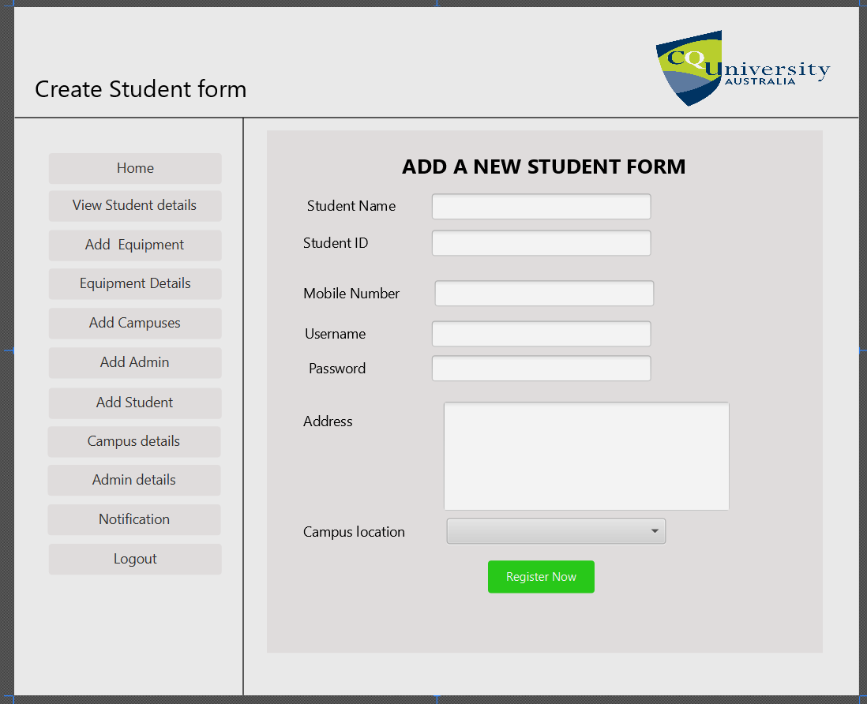

Figure : add student details

**4. View Student details**

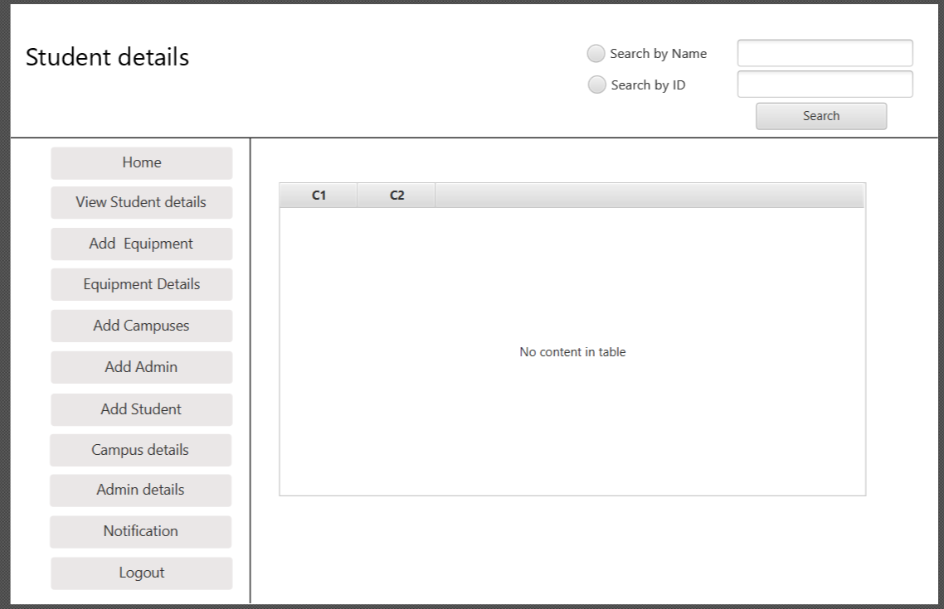

Figure : view student details

**5. Add New Admin**

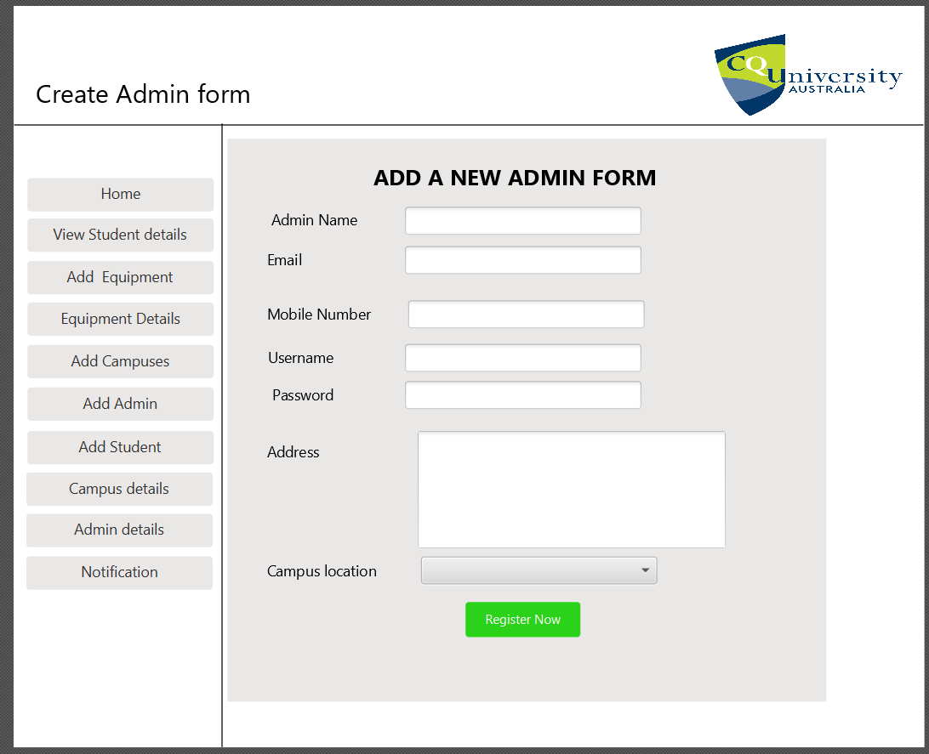

Figure : add new admin

**6. Admin details**

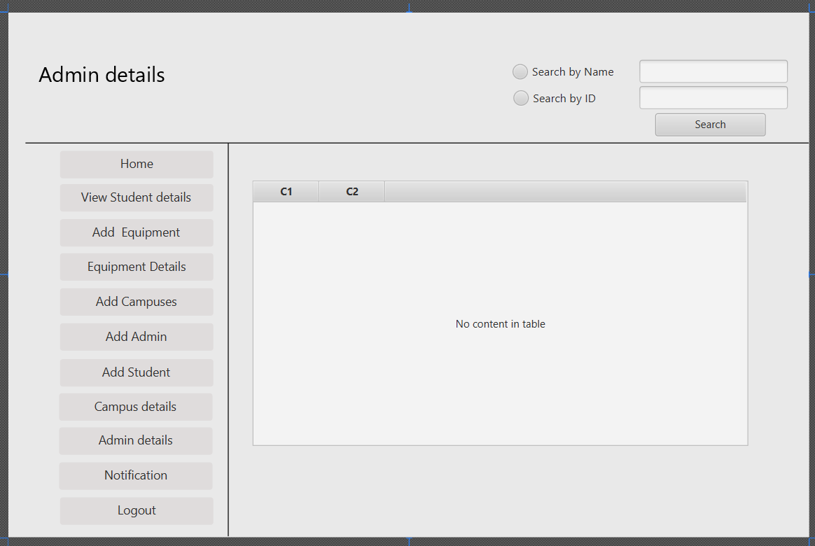

Figure : admin details

**7. Add Equipment**

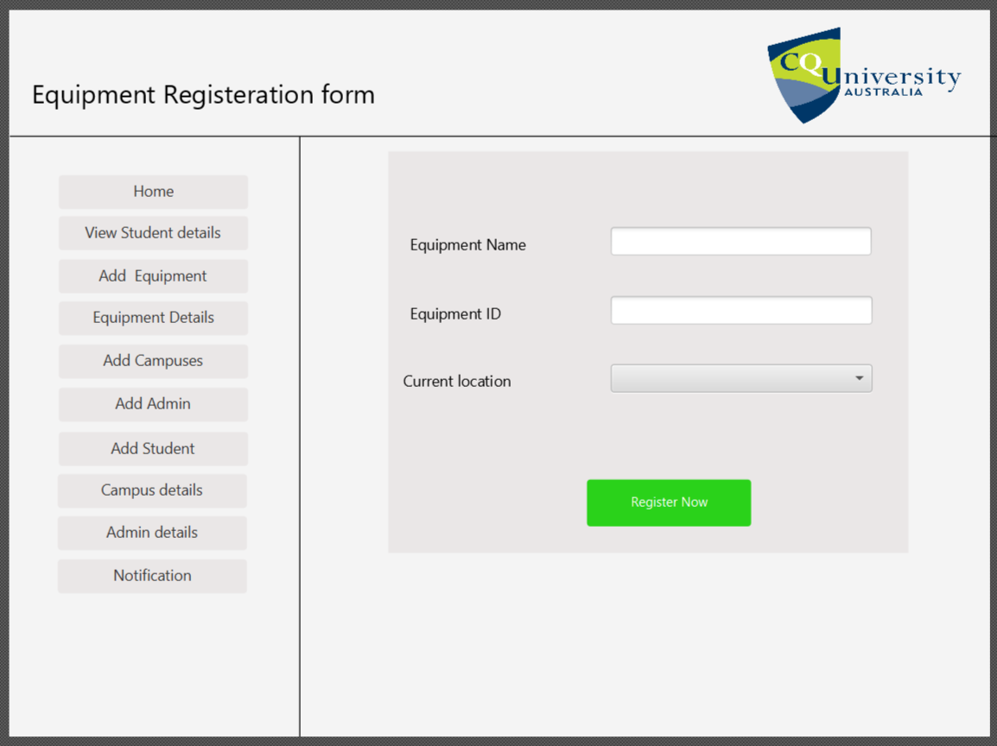

Figure : add equipment

**8. Equipment Search**

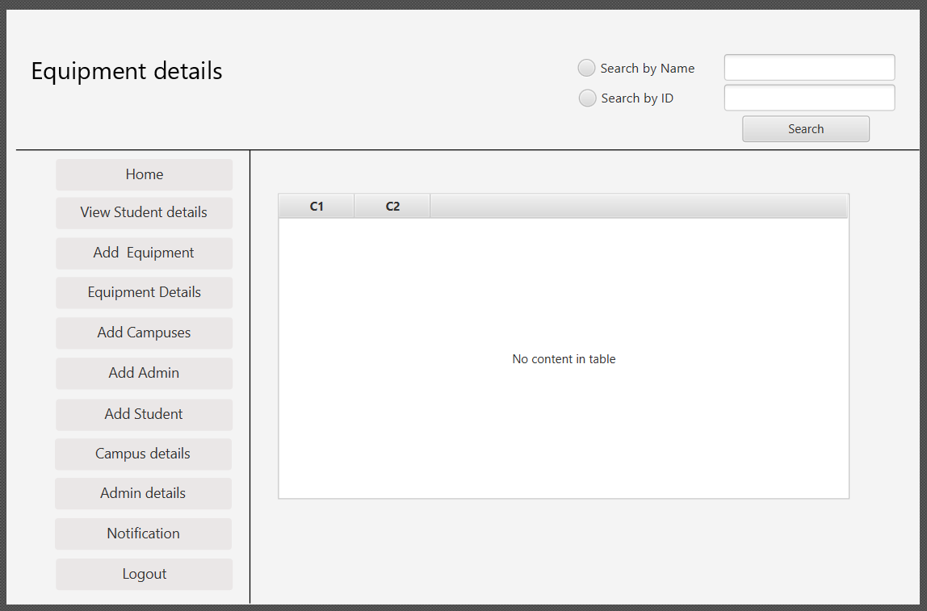

Figure : equipment search

**9. Campus Registration**

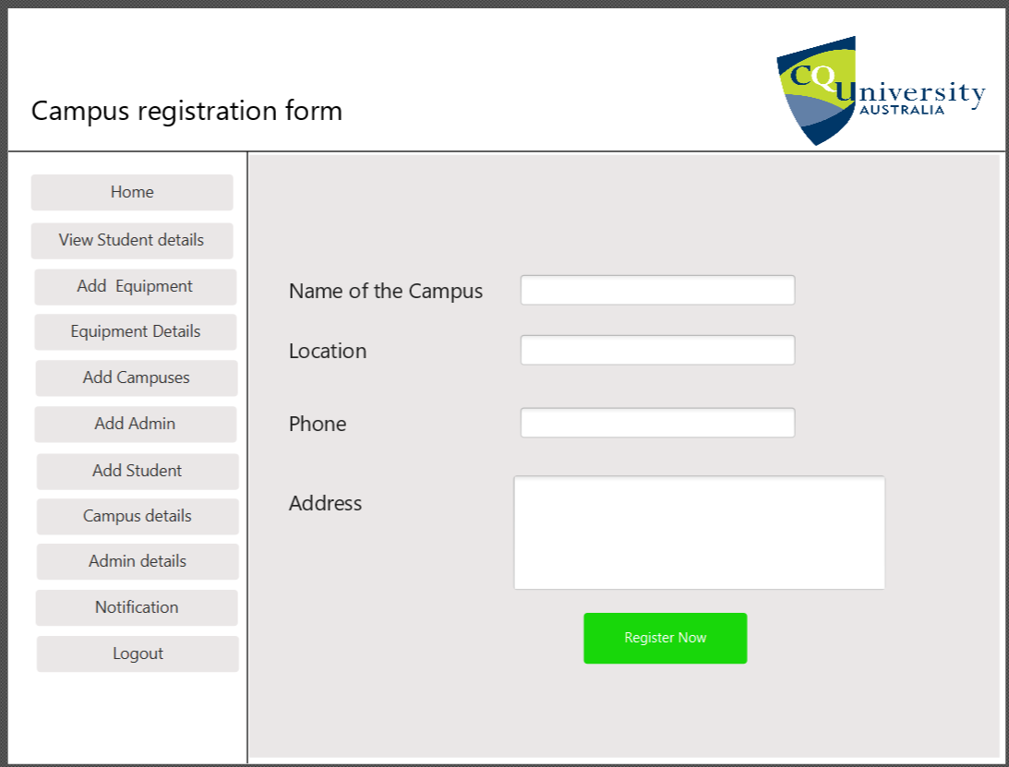

Figure : campus registration

**10. View Campuses details**

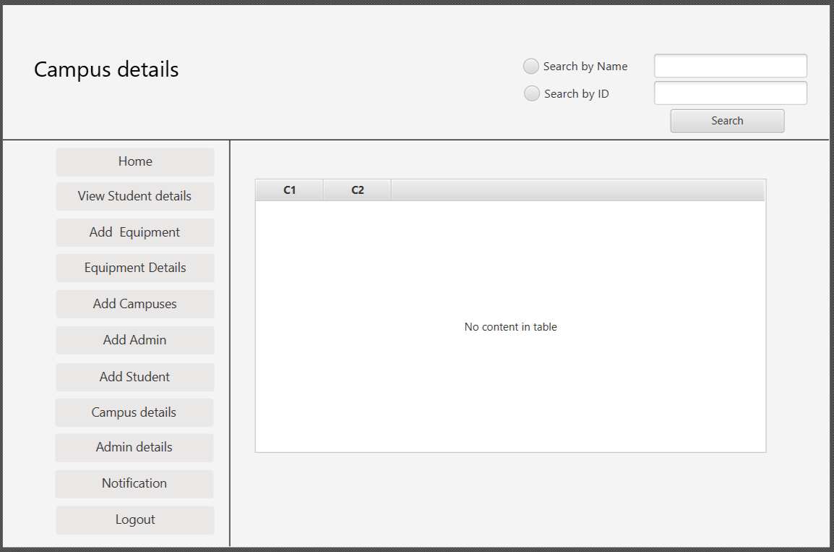

Figure : view campus details

# **Monitoring and reporting**

Monitoring is an important part in every project. It is the regular collection of information to track the implementation and measure the performance of the project. Monitoring provides project manager with data and information to implement the project.

Reporting is another important aspect in project development cycle. Every things regarding to the project must be report properly so that the problems encountered can be solved during implementation of the project. Project report is an essential part for project implementers to inform partners and stakeholders of the project. To monitor and report of the project the following activities will be done:

* Team Meeting:

Team meeting will be head in every 3 to 4 days interval where the team members and stakeholders will discuss over progress of the application. Because of the covid we are not able to have group discussion so we will be having meeting through zoom and any online media where we will discuss tasks completion, next phase, issues arises and solution of the issues.

* Weekly status report

Weekly status report will be submitted to the tutor by the group of the leader.

# **Reference list**

ALTVATER, A. (2017). *What is N-Tier Architecture? Examples, Tutorials & More*. [online] Stackify. Available at: https://stackify.com/n-tier-architecture/.

Baqais, A.A.B. and Alshayeb, M. (2018). Sequence diagram refactoring using single and hybridized algorithms. *PLOS ONE*, 13(8), p.e0202629.

Fowler, M. (2019). *Software Architecture Guide*. [online] https://martinfowler.com/architecture/. Available at: https://martinfowler.com/architecture/.

Sinhal, A. (2017). *MVC, MVP and MVVM Design Pattern*. [online] Medium. Available at: https://medium.com/@ankit.sinhal/mvc-mvp-and-mvvm-design-pattern-6e169567bbad.

slidetodoc.com. (n.d.). *Web Application Architecture multitier 2 tier 3 tier*. [online] Available at: https://slidetodoc.com/web-application-architecture-multitier-2-tier-3-tier/ [Accessed 7 Aug. 2021].

Watt, A. (2014). *Chapter 13 Database Development Process – Database Design – 2nd Edition*. [online] Opentextbc.ca. Available at: https://opentextbc.ca/dbdesign01/chapter/chapter-13-database-development-process/.

Francino, Y. (2019). *What is user story? - Definition from WhatIs.com*. [online] SearchSoftwareQuality. Available at: https://searchsoftwarequality.techtarget.com/definition/user-story.

Gracia, T. (2019). *What is a risk management plan?* [online] Reciprocity. Available at: https://reciprocity.com/resources/what-is-a-risk-management-plan/.

Grant, M. (2021). *Understanding Gantt Charts*. [online] Investopedia. Available at: https://www.investopedia.com/terms/g/gantt-chart.asp.

Rehkoph, M. (n.d.). *User Stories with Examples and Template*. https://www.atlassian.com/agile/project-management/user-stories.

Spacey, J. 2017. 7 Types of Feasibility Analysis. [Online]. [4 September 2021]. Available from: <https://simplicable.com/new/feasibility-analysis>

Richard daniels, R. 2021. What is Feasibility Study? 10 Types of Feasibility Study Explained. [Online]. [4 September 2021]. Available from: <https://www.businessstudynotes.com/finance/project-management/types-feasibility-study/>

# **APPENDIX**

## 17.1. APPENDIX A : Screenshots of all the user story implementations

## Admin Login

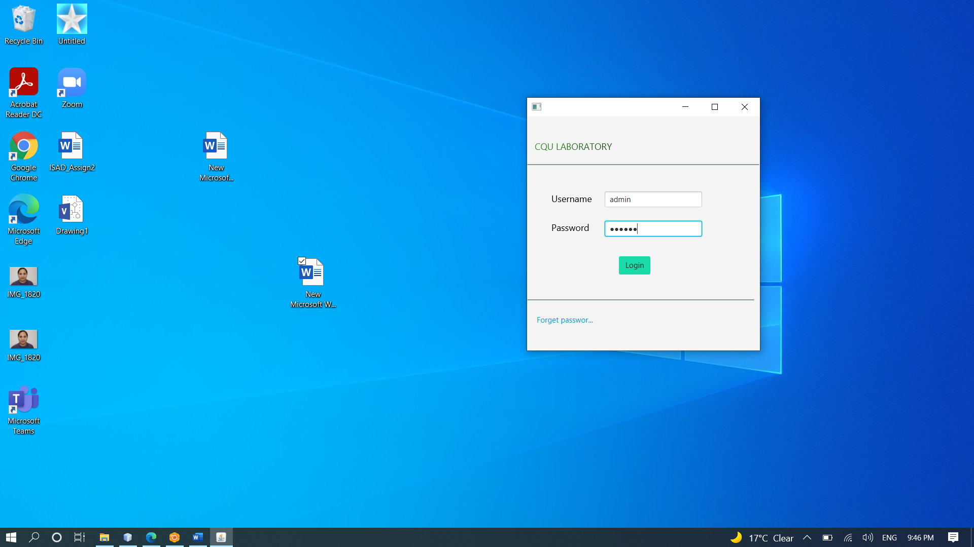

Figure 1 Admin Logging in from Login Page

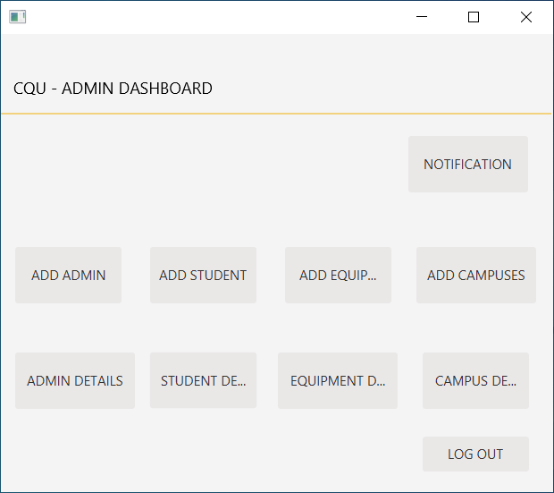

Figure 2 Admin Dashboard displayed after Admin Logged In

## Student Login

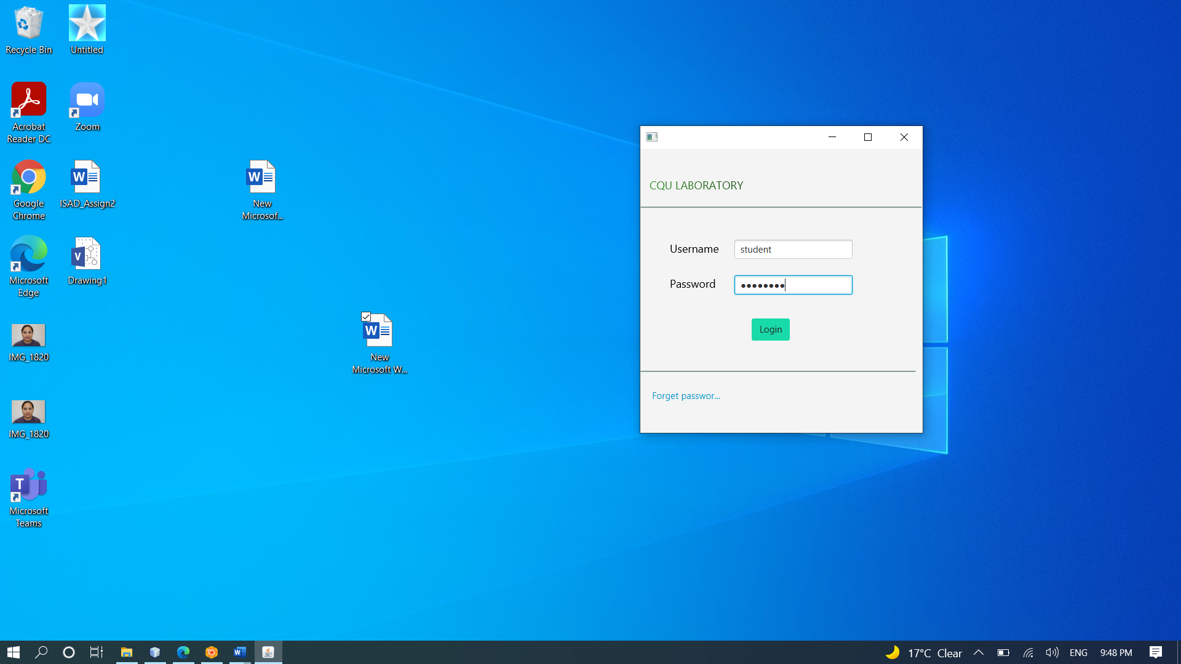

Figure 3 Member Logging in from Login Page

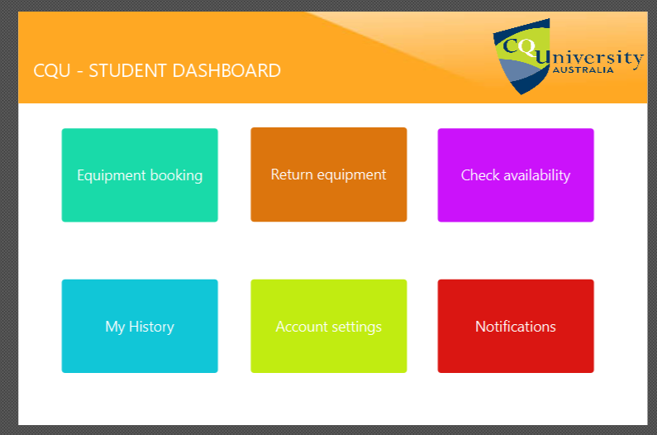

Figure 4 Member Dashboard displayed after Member Logged In

## Adding a new Administrator

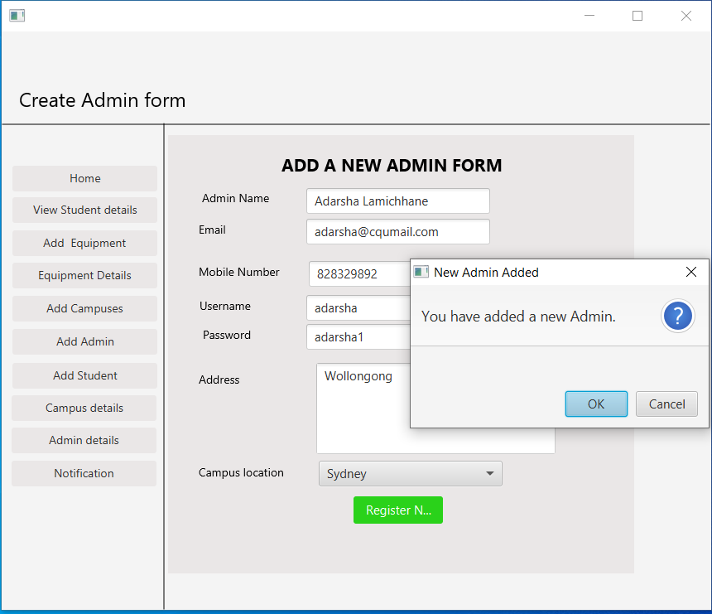

Figure 5 Adding a new Admin

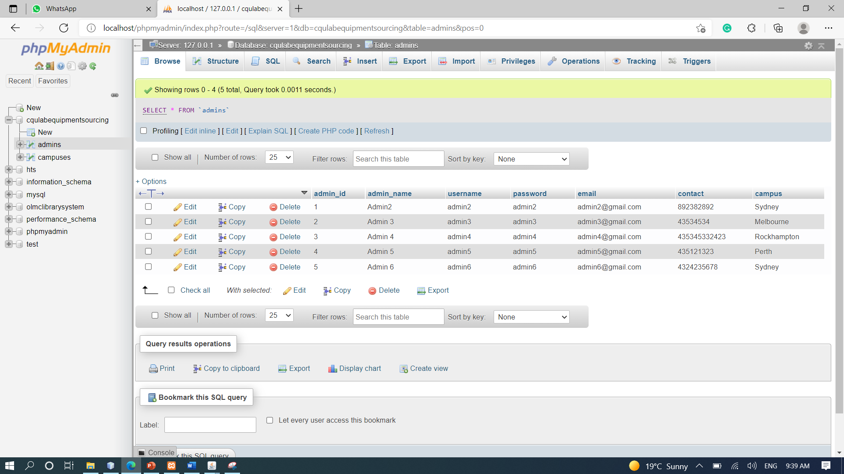

Figure 6 Database showing the addition of new Admin

## Adding a new Campus

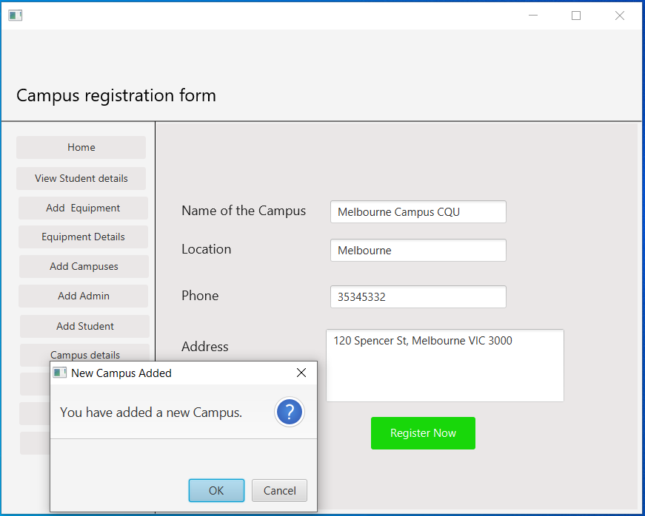

Figure 7 Adding a new Campus

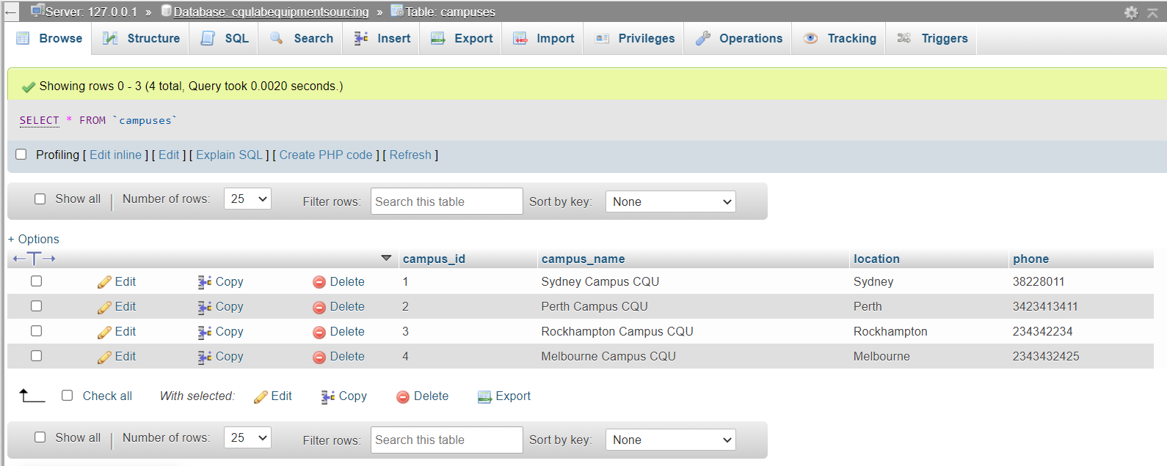

Figure 8 Database showing the addition of new Campus

## Admin Details Page

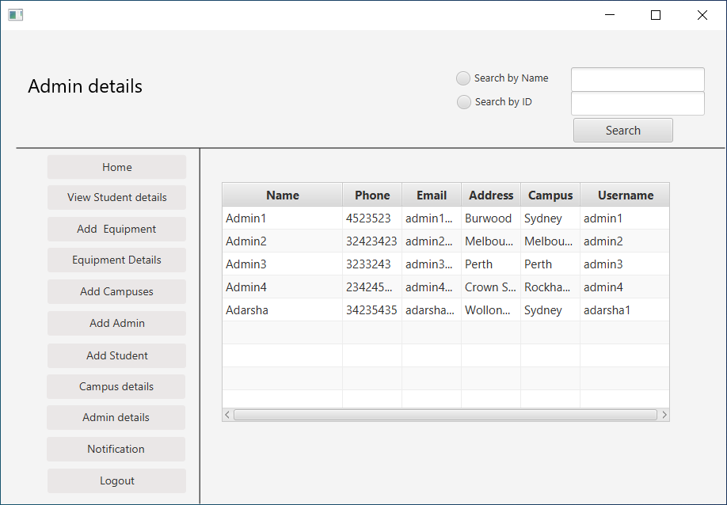

Figure 9 Admin Details Page

## Campus Details Page

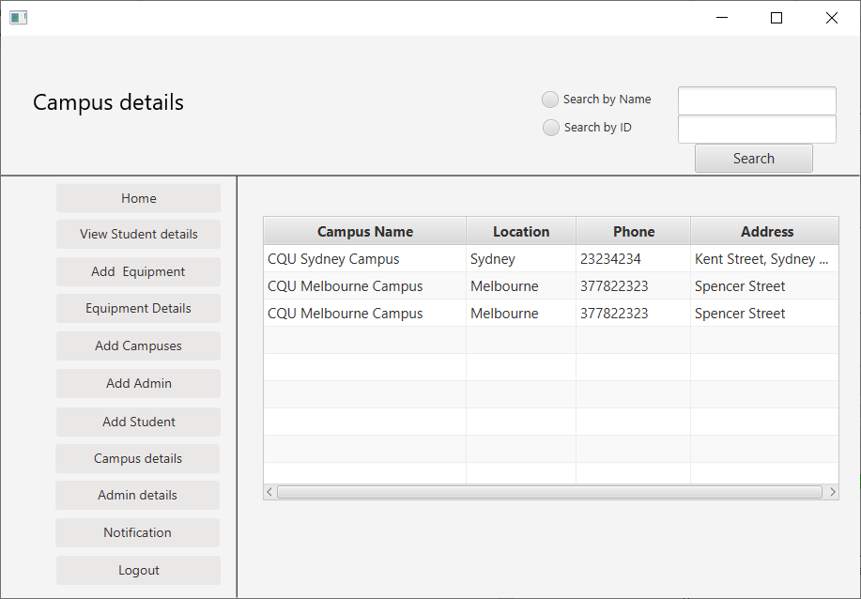

Figure 10 Campus Details Page

## Adding a new Student Form

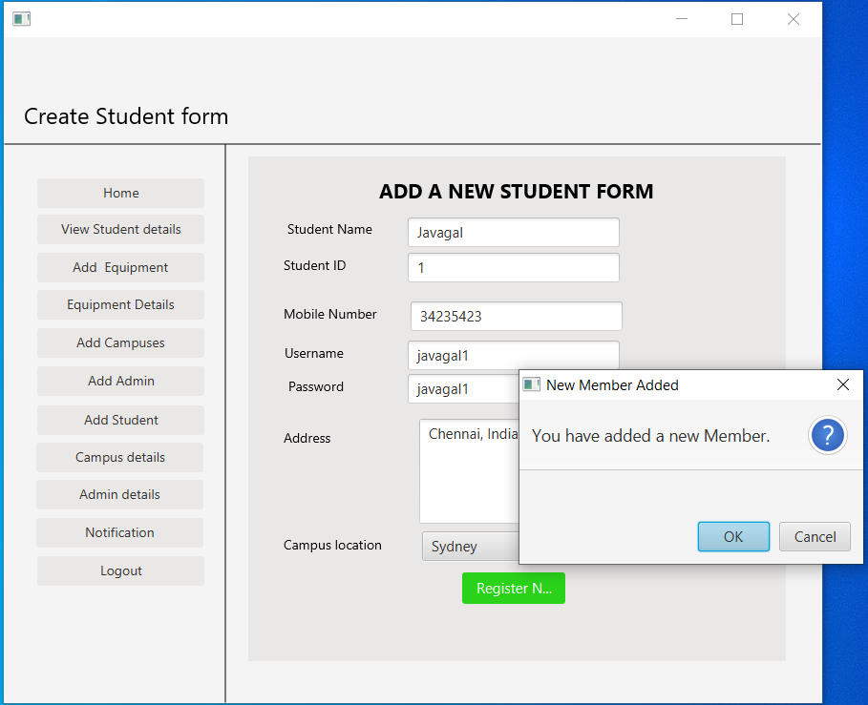

Figure 11 Add a new Student Form page

## Adding a new Equipment Form

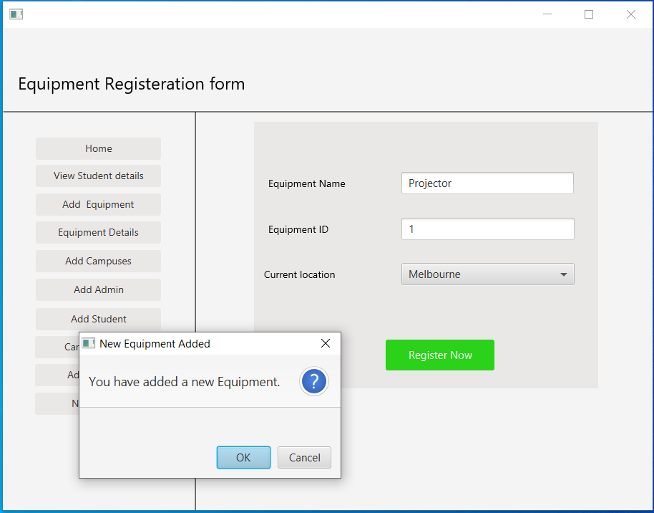

Figure 12 Equipment Registration Form page

## Student Details Page

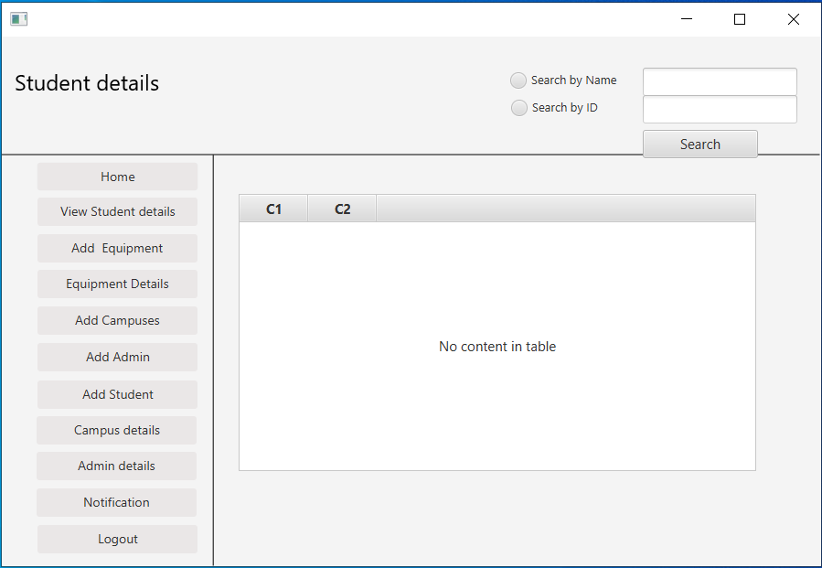

Figure 13 Student Details Page

## Equipment Details Page

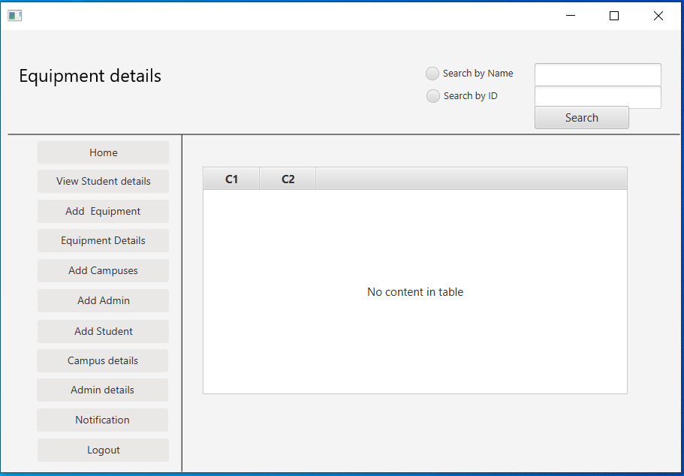

Figure 14 Equipment Search page